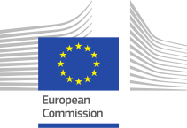
Fact Sheet

Multiple Intelligent Conversation Agent Services for Reception, Management and Integration of Third Country Nationals in the EU
WELCOME and its Objectives

The number of refugees in the world continues to grow from year to year. What seemed to be the absolute peak in 2015 / 2016 turned out to be just an outlook on what Europe has to be prepared for in the times to come. The reception and integration of Third Country Nationals (TCNs) remain a primary societal challenge for many EU countries. The challenge is threefold: (1) assistance of such a high number of people calls for allocation of significant resources; (2) TCNs who come to Europe do not form one homogeneous group; they have diverse educational, cultural, and social backgrounds that are all radically different from the European backgrounds; and (3) TCNs often are required to deal with more complex documentation than migrants from other European Economic Areas. This implies the need for a big effort in personalized communication, education (including language teaching) and cultural and social immersion. Personalization is the key. To address this challenge, the overall objective of WELCOME has been twofold:
A. To facilitate the reception and integration of TCNs through immersive technologies and intelligent conversational agents that act as dedicated personal assistants of TCNs in the contexts of
- Registration and orientation
- Linguistic and societal integration
- Coaching in everyday life
B. To support the work of the administrations and NGOs through intuitive visual analytics-based data analysis technologies targeting
- Knowledge & data correlation
- Knowledge & data visualization
- Decision support

Target Groups and Information Services
WELCOME focuses on catering information services to TCNs and administrations / NGOs in three European TCN host countries: Catalonia, Spain; Germany; and Greece.
Profile of the targeted TCNs:
Country of origin: Morocco
Gender: female and male
Age: 18 – 65
Provided services:
Information on Registration, First Reception Service, Topic-oriented Language Learning, Social Inclusion, Job Search Assistance, Schooling
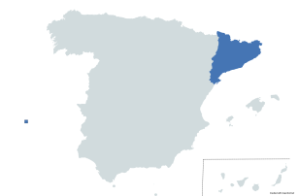

Profile of the targeted TCNs:
Country of origin: Syria, Iraq
Gender: female and male
Age: 18 – 65
Provided Services:
Appointment Arrangement, Job Search Assistance, Topic-oriented Language Learning, Social Inclusion, Schooling
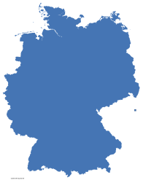
Profile of the targeted TCNs:
Country of origin: Iraq, Jordan, Syria
Gender: female and male
Age: 16 – 18; 20 – 45
Provided Services:
Legal service solicitation, Appointment arrangement, Housing, Job Search Assistance, Social Inclusion Topic-oriented Language Learning
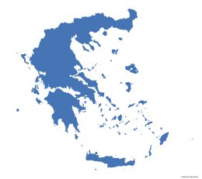

Shaping the WELCOME Technologies

Technologies Co-design
The key of successful technologies in the context of migration is co-design: All involved parties (TCNs, administrations, NGOs, and technical experts) must gather around the table in order to figure out the needs and the technical state of the art, to monitor the progress of the development, and to take corrective actions, if required. The WELCOME Consortium rigorously applied the technology co-design principle, following the following procedure:
Design the application scenario

Gather information on current state of the service
Gather information on current state of the service

Share progress and give feedback

Share ideas to see what is feasible

The result is the successful deployment of a mobile device-based MyWELCOME Application and a VR environment for the TCNs and a decision-support-oriented Visual Analytics Module for the stakeholders for a number of scenarios, matured in the course of the project in three SW development cycles.

Delivered WELCOME Technologies
The agents in WELCOME are aimed to have embodied multilingual conversation and decision support capabilities in order to address the specific needs of each TCN. They interact with the user in a real or virtual reality environment as well as with each other to interchange information and negotiate the best decision for each individual situation. The personalization of the interaction strategies is realized by considering the profile and the behaviour of the TCN. To ensure maximum adherence to cultural competency and flexibility to adapt to the many different cultural, religious, social and political diversities among TCNs, the design of the behaviour of the WELCOME agents is grounded in a thorough empirical study and co-creation. WELCOME also appreciates the added value of the virtual reality (VR) technologies. Interactive VR technologies have become increasingly prevalent as a means of improving knowledge and skill retention as well as provision of social and cultural values – increasingly in terms of “gamification”, which is growing within the business and training industries.
In this context, WELCOME deployed technologies the following technologies in four different research areas:
Agent planning and co-ordination & dialogue management services

Immersion & Interact-ion
Knowledge acquisition, representation and interpretation
Multilingual language technologies

- Social service plan-ning and selection
- Agent team coord-ination
- Hybrid context-aware dialogue manag-ement technologies
- Language identification
- Multilingual language analysis
- Multilingual language generation
- Machine translation

- Semantic represent-ation schemata
- Local & global know-ledge repositories
- Semantic reasoning & contextual awareness

- Immersive targeted language learning
- Gamification
- Virtual Reality env-ironments
- Agent embodiements

WELCOME furthermore acknowledges that the knowledge (personal data, level of language proficiency, degree of integration, etc.) acquired in personalized interaction with TCNs is essential for asserted decision making of the authorities related to TCN reception and integration as well as of the personnel involved, e.g., in language teaching to TCNs. To this end, WELCOME draws upon visual analytics techniques that form the backbone of decision support services.
Data and knowledge fusion and interpretation

Intuitive visualization techniques
Possibility of interfacing legacy data repositories
- Standard formats that facilitate the integration of User DBs (if desired)

- Standard configurable visualization techniques that ensure comprehension of complex data correlations

- Use of data and knowledge from local and global repositories
- Semantic Reasoning
- Data correlation
- Decision support

Project Timeline

The following diagram shows the timeline of the Project. Originally planned for 36 months, it has been extended by 3 months due to the COVID-19 pandemic.
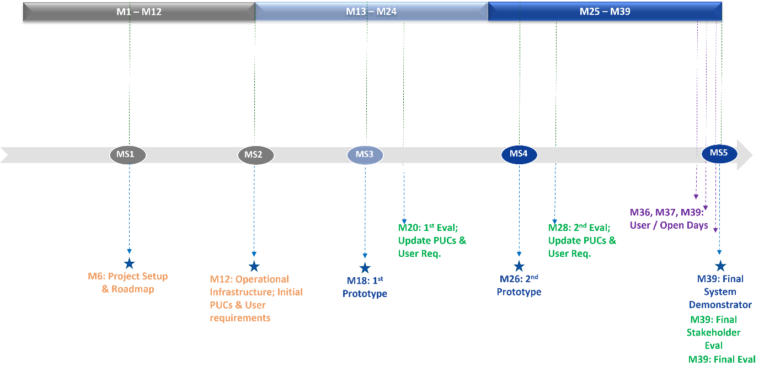
The progress of the Project has been monitored by five Milestones (MSs). MS1 (at Month 6) marked the successful Project setup and the delivery of the Roadmap for the development of the WELCOME Technologies. MS2 (at Month 12) stands for the realization of the Operational Infrastructure, i.e., the integration of the skeletons of the individual modules in a system architecture, and the initial definition of the User Requirements and of the Pilot Use Cases (PUCs), in the context of which the WELCOME technologies have been evaluated. The following three Milestones (MS3 at Month 18, MS4 at Month 26, and MS5 at Month 39) stand for the completion of the successive prototypes. MS3 and MS4 were followed by extensive assessment trials, in which TCNs and administrations / NGOs have been involved, and which resulted in the update of the PUCs and User Requirements. In the last phase of the Project, User Days have been organized in Athens, Greece and Hamm, Germany and an Open Day in Barcelona, Spain. An additional stakeholder evaluation took place in Month 39 in Thessaloniki, Greece.
Project Identity

Project Name WELCOME: Multiple Intelligent Conversation Agent Services for
Reception, Management and Integration of Third Country Nationals in
the EU

Coordination Prof. Dr. Leo Wanner, Catalan Institute for Research and Advanced
Studies and Pompeu Fabra University, Barcelona, Spain
leo.wanner@upf.edu

Consortium Universitat Pompeu Fabra (upf), Barcelona, Spain
Centre for Research and Technology, Hellas (CERTH), Thessaloniki,
Greece
Charles University (CUNI), Prague, Czech Republic
Brno University of Technology (BUT), Brno, Czech Republic
Deutsches Forschungszentrum für Künstliche Intelligenz
(DFKI),Saarbrücken, Germany
Sheffield Hallam University (SHU), Sheffield, United Kingdom
EVERIS (EVERIS), Barcelona, Spain
Nurogames GmbH (NUR), Cologne, Germany
Método Estudios Consultores SLU (METODO), Vigo, Spain
Mind Refuge (MR), Geiselbach, Germany
Kentro Meleton Asfaleias (KEMEA), Athens, Greece
Departament d’Igualtat i Feminismes, Generalitat de Catalunya (DIFE), Barcelona, Spain
CARITAS Verband Hamm e.V. (CARITAS), Hamm, Germany
PRAKSIS (PRAKSIS), Athens, Greece
iSocial Foundation (IS), Barcelona, Spain

Funding Scheme Horizon 2020 Framework in Research and Innovation (2014 – 2020) Europe in a changing world – Inclusive, innovative and reflective societies, DT-MIGRATION-06-2018-2019: Addressing the challenge of migrant integration through ICT-enabled solutions

Duration 1 February 2020 – 30 April 2023

Budget EC Contribution: 3,995,709.35 €

Website https://www.welcome-h2020.eu/

Contact For further information, contact Leo Wanner (leo.wanner@upf.edu)

